Unit 3 : **Advanced concepts on trees : BST (Binary Search Tree)**

In a binary tree, every node can have a maximum of two children but there is no need to maintain the order of nodes basing on their values. In binary tree, the elements are arranged in the order they arrive to the tree from top to bottom and left to right.

A binary tree has the following time complexities...

Search Operation - O(n)

Insertion Operation - O(1)

Deletion Operation - O(n)

To enhance the performance of binary tree, we use special type of binary tree known as Binary Search Tree. Binary search tree mainly focuses on the search operation in binary tree. Binary search tree can be defined as follows...

Binary Search Tree is a binary tree in which every node contains only smaller values in its left subtree and only larger values in its right subtree.

**Operations on a Binary Search Tree**

The following operations are performed on a binary search tree...

1. **Search**
2. **Insertion**
3. **Deletion**

**Search Operation in BST**

In a binary search tree, the search operation is performed with **O(log n)** time complexity. The search operation is performed as follows...

* **Step 1 -**Read the search element from the user.
* **Step 2 -**Compare the search element with the value of root node in the tree.
* **Step 3 -**If both are matched, then display "Given node is found!!!" and terminate the function
* **Step 4 -**If both are not matched, then check whether search element is smaller or larger than that node value.
* **Step 5 -**If search element is smaller, then continue the search process in left subtree.
* **Step 6-**If search element is larger, then continue the search process in right subtree.
* **Step 7 -**Repeat the same until we find the exact element or until the search element is compared with the leaf node
* **Step 8 -**If we reach to the node having the value equal to the search value then display "Element is found" and terminate the function.
* **Step 9 -**If we reach to the leaf node and if it is also not matched with the search element, then display "Element is not found" and terminate the function.

**Insertion Operation in BST**

In a binary search tree, the insertion operation is performed with **O(log n)** time complexity. In binary search tree, new node is always inserted as a leaf node. The insertion operation is performed as follows...

* **Step 1 -**Create a newNode with given value and set its **left** and **right** to **NULL**.
* **Step 2 -**Check whether tree is Empty.
* **Step 3 -**If the tree is **Empty**, then set **root** to **newNode**.
* **Step 4 -**If the tree is **Not Empty**, then check whether the value of newNode is **smaller** or **larger** than the node (here it is root node).
* **Step 5 -**If newNode is **smaller** than **or equal** to the node then move to its **left** child. If newNode is **larger** than the node then move to its **right** child.
* **Step 6-**Repeat the above steps until we reach to the **leaf** node (i.e., reaches to NULL).
* **Step 7 -**After reaching the leaf node, insert the newNode as **left child** if the newNode is **smaller or equal** to that leaf node or else insert it as **right child**.

**Deletion Operation in BST**

In a binary search tree, the deletion operation is performed with **O(log n)** time complexity. Deleting a node from Binary search tree includes following three cases...

Case 1: Deleting a Leaf node (A node with no children)

Case 2: Deleting a node with one child

Case 3: Deleting a node with two children

**Case 1: Deleting a leaf node**

We use the following steps to delete a leaf node from BST...

* **Step 1 - Find** the node to be deleted using **search operation**
* **Step 2 -**Delete the node using **free** function (If it is a leaf) and terminate the function.

**Case 2: Deleting a node with one child**

We use the following steps to delete a node with one child from BST...

* **Step 1 - Find** the node to be deleted using **search operation**
* **Step 2 -**If it has only one child then create a link between its parent node and child node.
* **Step 3 -**Delete the node using **free** function and terminate the function.

**Case 3: Deleting a node with two children**

We use the following steps to delete a node with two children from BST...

* **Step 1 - Find** the node to be deleted using **search operation**
* **Step 2 -**If it has two children, then find the **largest** node in its **left subtree** (OR) the **smallest** node in its **right subtree**.
* **Step 3 - Swap** both **deleting node** and node which is found in the above step.
* **Step 4 -**Then check whether deleting node came to **case 1** or **case 2** or else goto step 2
* **Step 5 -**If it comes to **case 1**, then delete using case 1 logic.
* **Step 6-**If it comes to **case 2**, then delete using case 2 logic.
* **Step 7 -**Repeat the same process until the node is deleted from the tree.

##### Example

Construct a Binary Search Tree by inserting the following sequence of numbers...

#### 10,12,5,4,20,8,7,15 and 13

Above elements are inserted into a Binary Search Tree as follows...

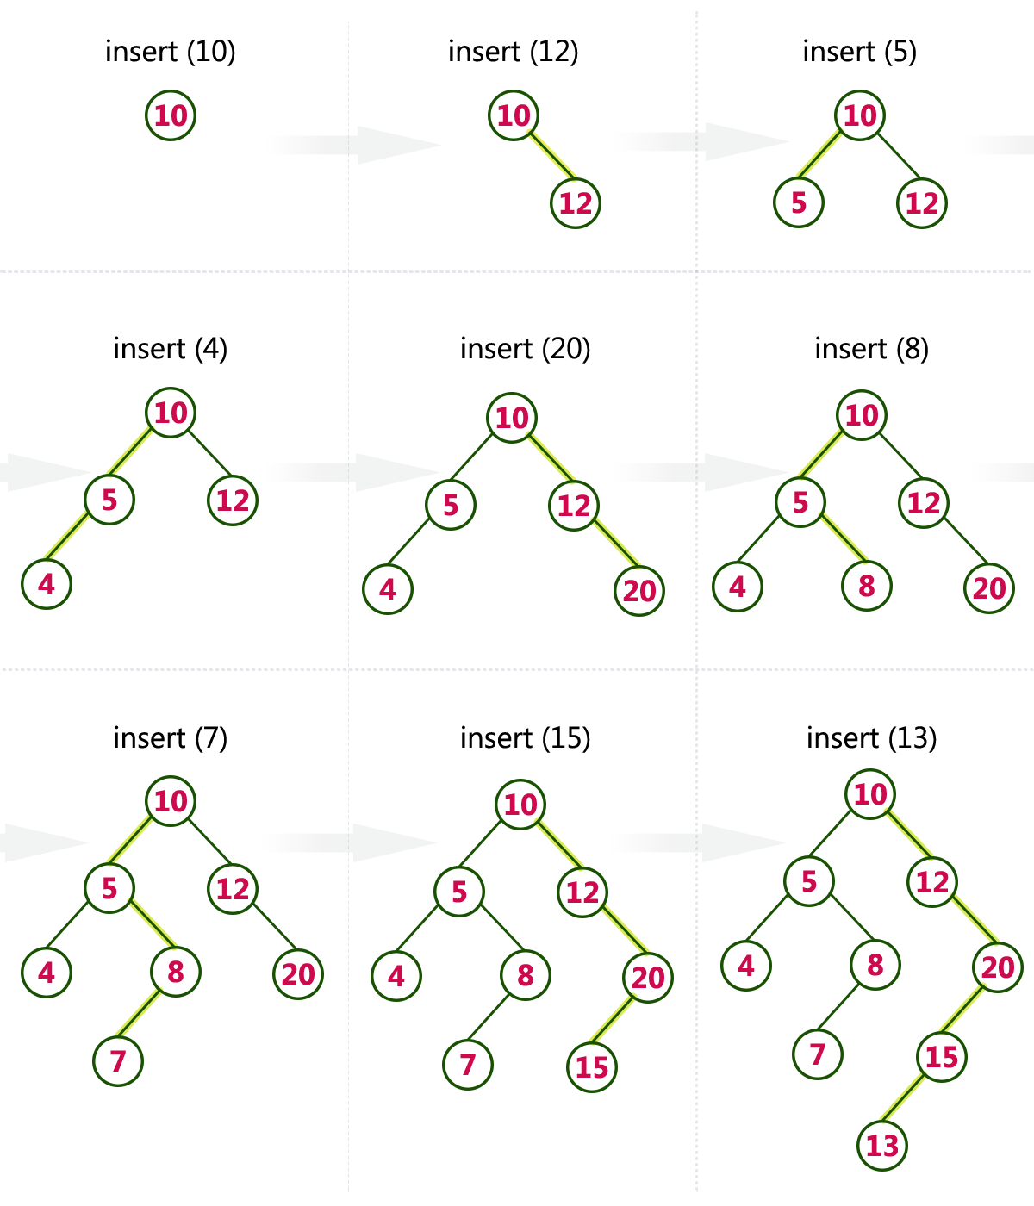

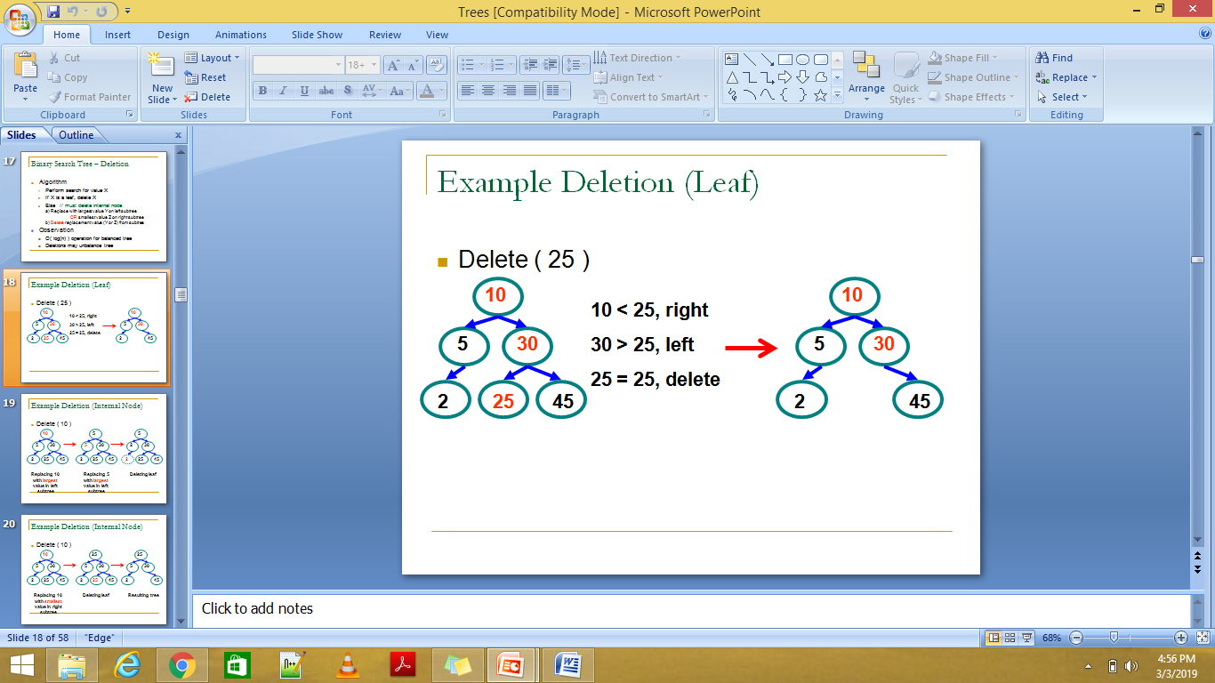

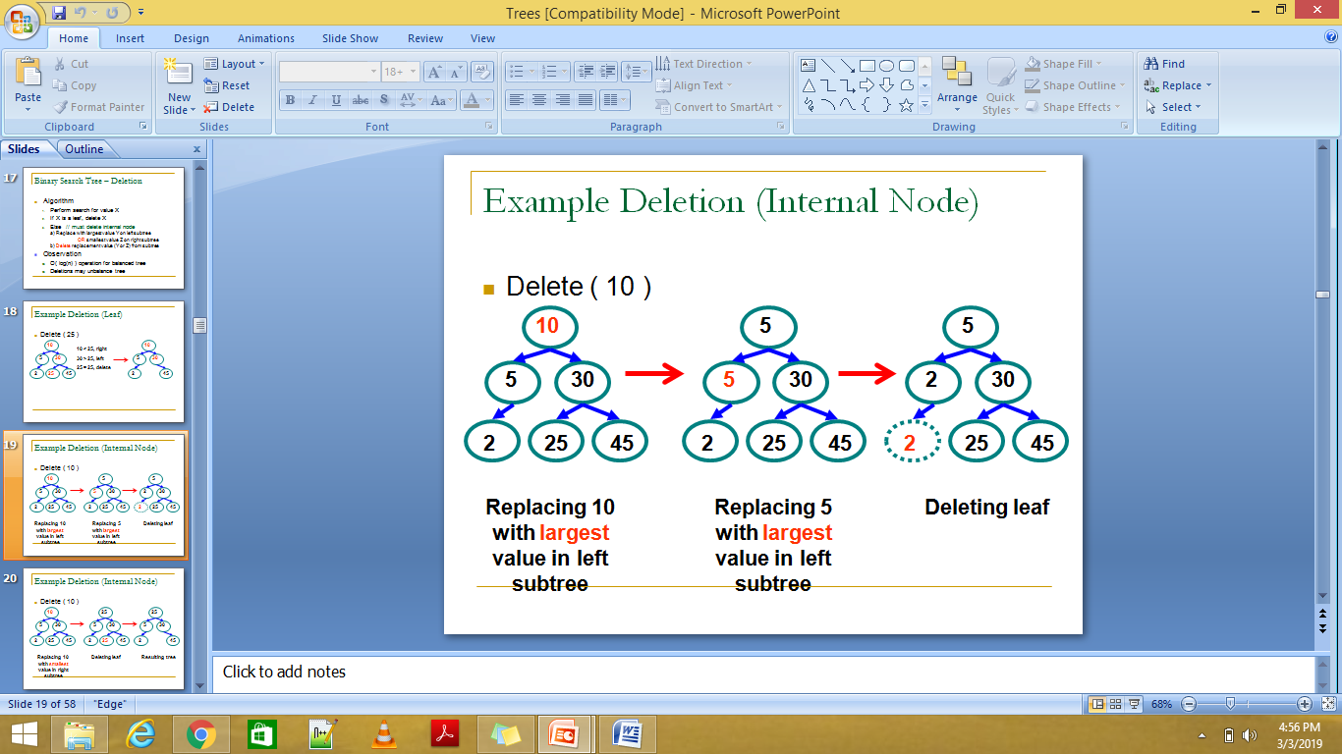

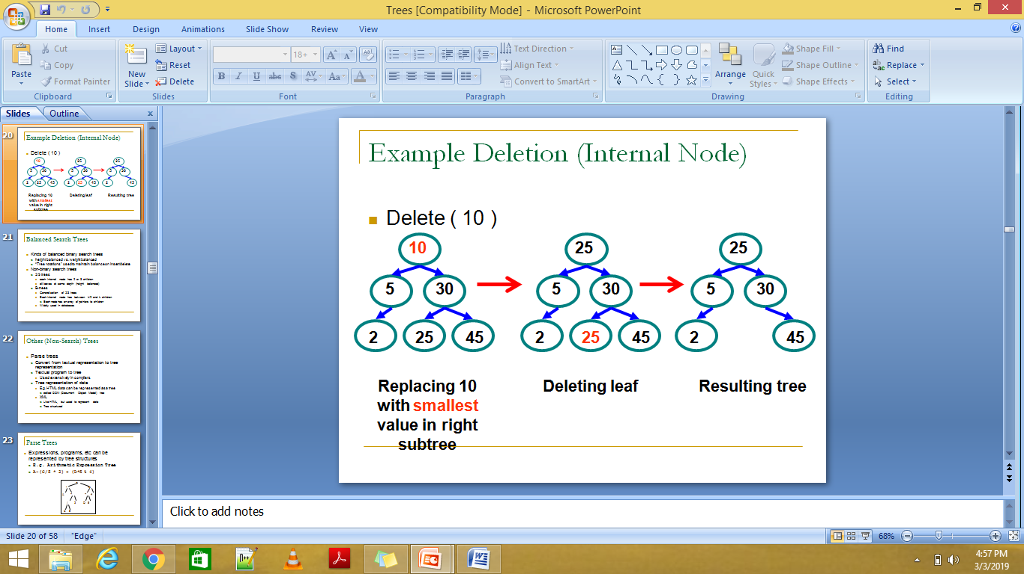

**Implementation of BST**

/* create BST and perform insert,delete, Inorder,Preorder and Postorder on it.

1.Insert 2.inorder 3.preorder 4.postorder 5.delete 6.Exit

Enter your choice : 1

Enter data of node to be inserted : 10

1.Insert 2.inorder 3.preorder 4.postorder 5.delete 6.Exit

Enter your choice : 1

Enter data of node to be inserted : 8

1.Insert 2.inorder 3.preorder 4.postorder 5.delete 6.Exit

Enter your choice : 1

Enter data of node to be inserted : 15

1.Insert 2.inorder 3.preorder 4.postorder 5.delete 6.Exit

Enter your choice : 2

8 -> 10 -> 15 ->

1.Insert 2.inorder 3.preorder 4.postorder 5.delete 6.Exit

Enter your choice : 5

Enter data of node to be deleted : 15

Inorder traversal: 8 -> 10 ->

*/

#include <stdio.h>

#include <stdlib.h>

struct node{

int data;

struct node *left;

struct node *right;

}*root = NULL, *temp,*start = NULL;

void insert();

void inorder(struct node *);

void preorder(struct node *);

void postorder(struct node *);

//Find the inorder successor

struct node *minValueNode(struct node *node)

{ struct node *current = node;

// Find the leftmost leaf

while (current && current->left != NULL)

current = current->left;

return current;

}

struct node *deleteNode(struct node *root, int key) {

// Return if the tree is empty

if (root == NULL)

return root;

// Find the node to be deleted

if (key < root->data)

root->left = deleteNode(root->left, key);

else if (key > root->data)

root->right = deleteNode(root->right, key);

else {

// If the node is with only one child or no child

if (root->left == NULL) {

temp = root->right;

free(root);

return temp;

} else if (root->right == NULL) {

temp = root->left;

free(root);

return temp;

}

// If the node has two children

temp = minValueNode(root->right);

// Place the inorder successor in position of the node to be deleted

root->data = temp->data;

// Delete the inorder successor

root->right = deleteNode(root->right, temp->data);

}

return root;

}

int main()

{

int ch,ele,x;

do

{

printf("\n1.Insert 2.inorder 3.preorder 4.postorder 5.delete 6.Exit");

printf("\nEnter your choice : ");

scanf("%d", &ch);

switch (ch)

{

case 1:

insert(); break;

case 2:

inorder(root);break;

case 3:

preorder(root);break;

case 4:

postorder(root);break;

case 5:

printf("Enter data of node to be deleted : ");

scanf("%d", &x);

root = deleteNode(root, x);

printf("Inorder traversal: "); inorder(root);

break;

case 6:

exit(0);

default :

printf("Wrong choice, Please enter correct choice ");

break;

}

}while(ch<=3);

}

/* To insert a node in the tree */

void insert()

{

start=root;

temp = (struct node *)malloc(sizeof(struct node));

printf("Enter data of node to be inserted : ");

scanf("%d", &temp->data);

temp->left = temp->right = NULL;

if (root == NULL)

root = temp;

else

{

while(1)

{

if(temp->data<start->data)

{

if(start->left==NULL)

{

start->left=temp;

break;

}

start=start->left;

}

if(temp->data>start->data)

{

if(start->right==NULL)

{

start->right=temp;

break;

}

start=start->right;

}

}

}

}

void inorder(struct node *temp)

{

if(temp!=NULL)

{

inorder(temp->left);

printf("%d -> ", temp->data);

inorder(temp->right);

}

}

void preorder(struct node *temp)

{

if(temp!=NULL)

{

printf("%d -> ", temp->data);

preorder(temp->left);

preorder(temp->right);

}

}

void postorder(struct node *temp)

{

if(temp!=NULL)

{

postorder(temp->left);

postorder(temp->right);

printf("%d -> ", temp->data);

}

}